Visualization analysis of the average salary by title indicates a several strange discrepancies in compensation:

* Sr. Engineer / Engineer / Assistant Engineer have equivalent salaries (Sr Engineer should be notably higher than Engineer, notably higher than Assistant Engineer)
* Staff & Sr. Staff have equivalent salaries (Sr. Staff should be notably higher)
* Managers are less compensated lower than Staff / Sr. Staff (generally not the case)
* Technique Leader appears to be the lowest paid (generally they are among the highest paid).

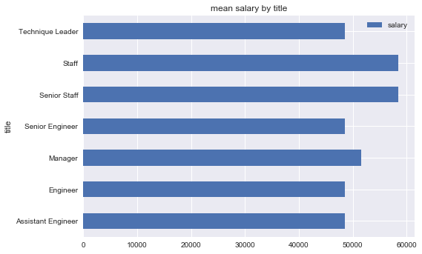

The maximum salaries also show similar discrepancies

* Maximum salary for a manager is the lowest (even lower than an assistant engineer)
* Staff & Sr. Staff again show equivalent maximums
* Sr. Engineer and Engineer show equivalent maximums

